NOTICE OF SPECIAL LIVERMORE CITY ELECTION
Notice is hereby given that a Special Livermore City Election to elect City Mayor will be held on Tuesday, April 4, 2023.
Polls in Livermore will open at 7:00 a.m. and close at 8:00 p.m.
Immanuel Lutheran Church, 304 4th Ave, Livermore, Iowa

VOTER PRE-REGISTRATION
Pre-registered voters are required to provide an approved form of identification at the polling place before receiving and casting a regular ballot. Eligible electors who are not pre-registered, such as voters registering to vote on Election Day, and voters changing precincts must also provide proof of residence. A voter who is unable to provide an approved form of identification or prove residence if required, may:
- Have voter’s identity/residence attested to by another registered voter in the precinct
- Prove identity and residence using Election Day Registration documents, or
- Cast a provisional ballot and provide proof of identity/residence at the County Auditor’s office by April 6, 2023 at 9:00 a.m.

Election Day Registrant attesters must provide an approved form of identification. For additional information about pre-registration visit: https://sos.iowa.gov/elections/voterinformation/voterregistration.html or phone 515 332-1571.

ABSENTEE VOTING
Absentee ballots are available in the County Auditor’s office during regular business hours of 8:00 a.m. to 4:30 p.m. Or you may visit the Iowa Secretary of State website at https://sos.iowa.gov/elections/electioninfo/absenteeinfo.html for more information.

Any voter who is physically unable to enter a polling place has the right to vote in the voter’s vehicle. For further information, please contact the County Auditor’s office at the telephone number or e-mail address listed below.
Telephone: 515 332-1571 E-mail address: terickson@humboldtcountyia.org

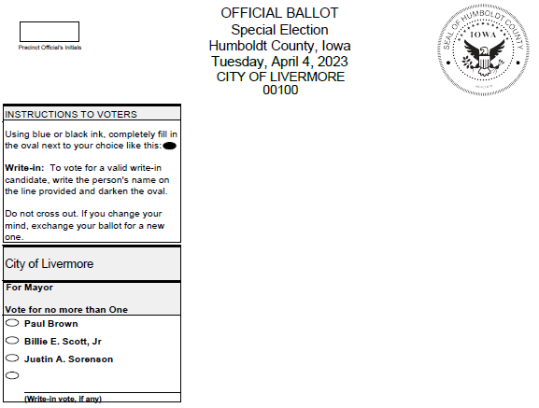

Certified by: Trish Erickson
Humboldt County Auditor
^{and} Commissioner of Elections

